THIRD SUBSISTENCE MARKETPLACES BOTTOM-UP IMMERSION CONFERENCE

https://cba.lmu.edu/immersionconference/

Sponsored By Center for International Business Education (CIBE), Loyola Marymount University

Conference dates June 3-6, 2020, Puebla, Mexico (2 hour shuttle drive from Mexico City Airport, Please wait to make travel arrangements until dates are confirmed by January 15, 2020)

Immediately follows the 8th Subsistence Marketplaces Conference at Loyola Marymount University, Los Angeles, May 30-June 1 (https://cba.lmu.edu/subsistencemarketplaces/) with June 2 being a possible travel day (the 8th conference immediately follows the Marketing and Public Policy Conference at the same location, May 28-30 - https://www.ama.org/events/conference/2020-ama-marketing-and-public-policy-conference/)

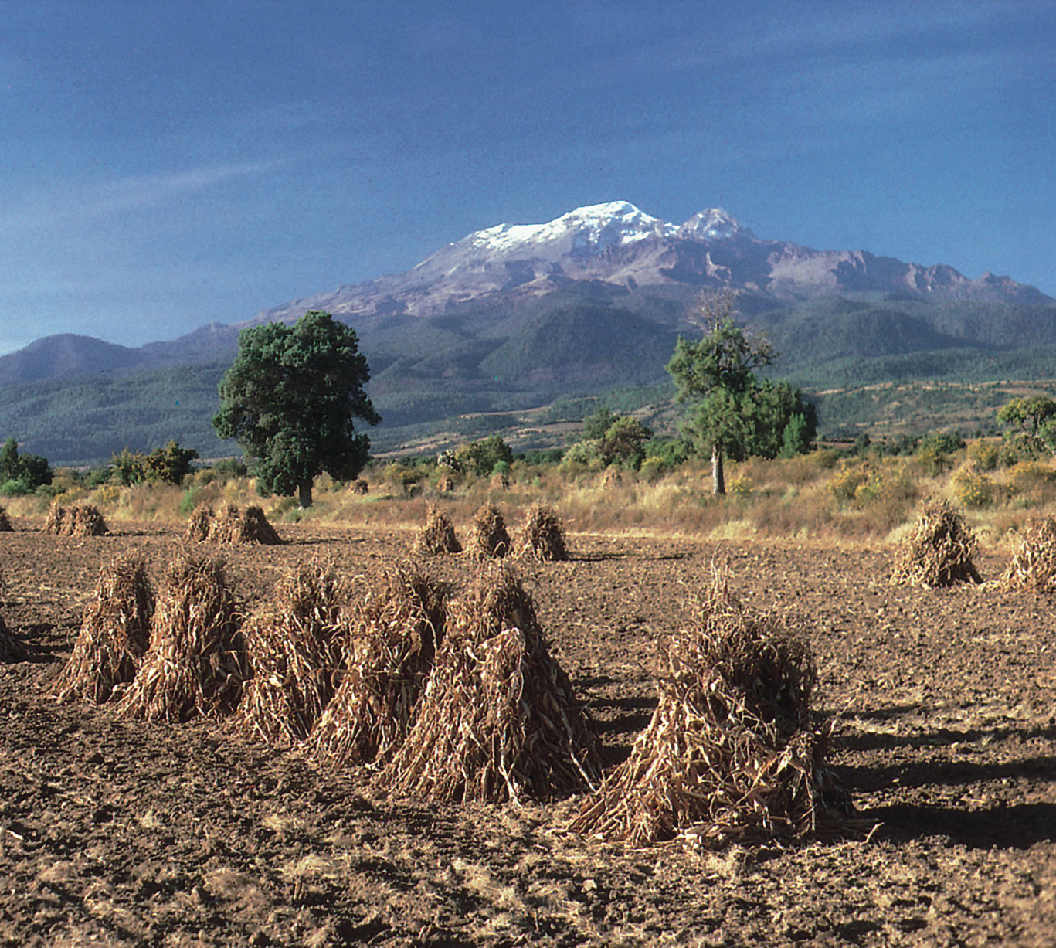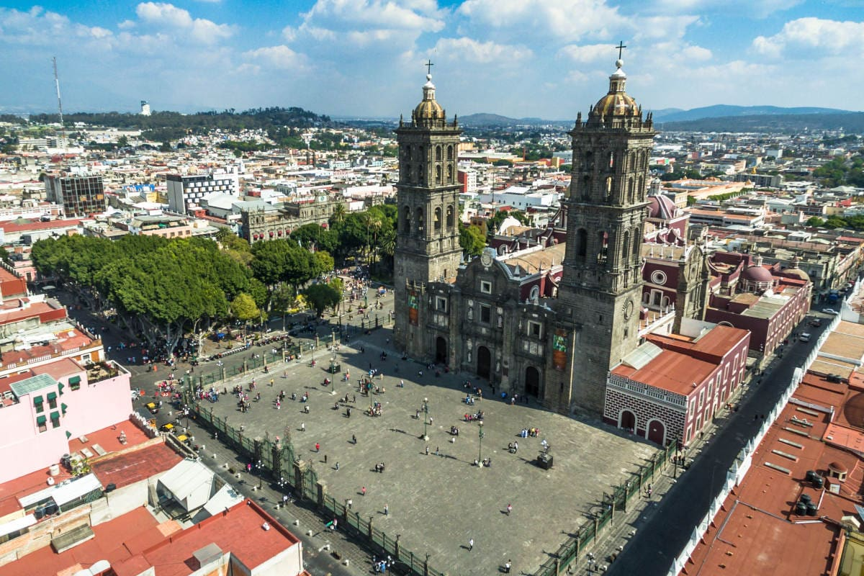

Deadline – January 10, 2020

About
This is an informal description of the thinking behind the third subsistence marketplaces bottom-up immersion conference. We invite you to read and consider participating in this unique, one-of-a-kind forum.

Conference Description
The stream of subsistence marketplaces has pioneered a unique, bottom-up approach to research, education, and practice at the intersection of poverty and marketplaces. Building on seven biennial conferences and two immersion conferences in the last 13 years and accompanying publications, we now announce the third immersion conference on subsistence marketplaces. True to the bottom-up approach that characterizes the subsistence marketplaces stream, this new series of conferences is envisioned to take place in different continents over time, thus providing an opportunity for researchers, educators, practitioners, and students to engage directly with urban and rural subsistence marketplaces, through conversations and observations.
Our third immersion conference will be held in Puebla, Mexico, with field visits in rural, semi-urban and urban settings, as well as social enterprises.

Why is this conference unique?
This is a bottom-up immersion conference. What this means is that we emphasize field interactions. If we are truly bottom-up in the subsistence marketplaces stream, then our forums should push further and be spent in the field as well, gaining bottom-up insights.

What will happen at the conference?
We will spend much of the day in the field, then return to Puebla to reflect and regroup for the next day. We remain fluid in allowing ideas from the participants and insights from the field to emerge and guide the process. Our process is bottom-up in this aspect as well, but guided by much experience, which will provide appropriate top-down structure.

What else can we do?
A lot! Here is just a small sample - https://www.tripadvisor.com/Attractions-g152773-Activities-Puebla_Central_Mexico_and_Gulf_Coast.html

Who makes this happen?
A symbiotic relationship between the Subsistence Marketplaces Initiative pioneered at the University of Illinois, and extended to Loyola Marymount University, Los Angeles, and the Marketplace Literacy Project (MLP), partnering with UDEM (Monterrey), UPAEP (Puebla), Monterrey Tec (Monterrey) and local social enterprises. Together, our marketplace literacy program has reached thousands of women and girls in several provinces in Mexico. This is a unique model of symbiotic academic-social enterprise and these entities are deeply embedded in communities, which will enable field interactions for conference participants.

What is the process building up to the conference?
Track chairs will be responsible for leading small groups of 4-8 people to the field with a trained translator. Please email us if you are interested in being a track chair. We envision rural and urban visits as the venues for observations and interviews, with a period in the Spring when we align groups and encourage interactions based on interests and preferences. We aim for fluidity during the conference, for people to move between groups. We plan to seek initial preferences from each group as to what they want to see and with whom they want to interact – the latter ranging from individuals to households, communities, leaders/experts, and enterprises.

What this conference is NOT
This conference is not a forum for conducting research, which, of course, requires a variety of procedures and formalities. Therefore, the focus instead is on field interactions, which are intended to stimulate discussion but do not constitute the basis for any formal research.

How to Apply
First, complete a simple form at https://cba.lmu.edu/immersionconference/application that asks the following:
· An overview of your interests (research, education, social enterprise, business, government, other) as they relate to subsistence marketplaces.
· An outline of how your topic enhances understanding of and well-being in subsistence marketplaces.
· A description of how/why immersive experiences will help you develop deeper insights into your topic of interest.
· Your prior experiences in subsistence marketplaces (if any). Note that prior experience in this area is NOT a requirement. In fact, we want to encourage those without prior experience to participate.
In addition to indicating your intention to participate which can be done right away, we will need you to complete a separate registration form to process your payment for the conference that will be open soon. Both forms can be found on the conference website.

Who can apply?
We invite academics, researchers, educators, practitioners and students who are interested in gaining first-hand experience in subsistence marketplaces. Although prior research or professional experience in subsistence marketplaces is not necessary, we expect participants to have topics related to subsistence marketplaces that they plan to pursue in their future research, education, or practice.

Background Information
For almost 15 years, the Subsistence Marketplaces Conference Series has been a leading biennial forum for evolving and sharing research, education, and fostering best practices for social and commercial enterprises in subsistence marketplace communities.
Scholars and practitioners around the world have participated in these forums through conferences, publications, and educational initiatives, beginning with the first Subsistence Marketplaces Conference in 2006. Research by this community has appeared in a variety of outlets, sustained through a series of special issues/sections in academic journals (with more than 50 articles in conference-related special publications and many more in other outlets).
Since its origin, subsistence marketplace research has accumulated a substantial body of knowledge paralleling other approaches to poverty, such as the capabilities approach and base-of-the-pyramid research, providing unique and complementary insights.
The term “subsistence marketplaces” was deliberately coined to reflect the need to study these marketplaces across resource and literacy barriers in their own right, beyond being new markets for companies. Business and exchange happens in many different ways across the world. Such exchanges are worthy of study from the inside out as well as the outside in. The term “marketplaces” denotes this focus and emphasizes the need to understand preexisting marketplaces before designing or presuming solutions.
More information on the Subsistence Marketplaces Initiative can be found at https://www.business.illinois.edu/subsistence/.

Approximate costs
Lodging
$50-60 plus taxes per night (likely)
Registration
Academic: $500 (Students $200)
Non-academic: $800
Special rate for Latin American residents:
Academic: $200 (Students $50)
Non-academic: $300

FOR MORE INFORMATION
https://cba.lmu.edu/immersionconference/
and
https://pages.business.illinois.edu/subsistence/conferences/

CONFERENCE DIRECTORS
Madhu Viswanathan, Loyola Marymount University
marketplaceliteracy@gmail.com
and

Ronald Duncan, University of Illinois, Urbana-Champaign, & Marketplace Literacy Project, USA

CONFERENCE CO-CHAIRS

Leticia Ivonne López Villarreal, Universidad de Monterrey, (UDEM), México

Radovan Pérez Restovic, Universidad Popular Autónoma del Estado de Puebla / UPAEP

Lumi (Luz) Maria Velazquez Sanchez, Monterrey Tec

Jacob Park, Rutgers University

CONFERENCE CONVENERS

Cristy Azuara
Elena Olascoaga

STUDENT COORDINATORS

Ana Karen Garza Martinez (UDEM)
Arun Sreekumar (University of Illinois, Urbana-Champaign)

PRACTITIONER COORDINATORS

Steven Morse
Steven Spreiser

CONFERENCE TRACK CHAIRS - IN PROGRESS
John Clarke, Tulane University
Michelle Reina, University of Mary Hardin-Baylor
Tejinder Sharma, Kurukshetra University
Maguemati Wabgou, Universidad Nacional De Colombia

