MIGRATION AND ORGANIZATIONS CONFERENCE
The Wharton School, University of Pennsylvania
October 21-22, 2022

Call For Papers (Submit by August 15, 2022)

Now in its fifth edition, this gathering seeks to advance rigorous research and strengthen the community of scholars at the intersection of migration and organizations. We invite papers linking migration to topics such as:

- Organizational performance
- Employee mobility
- Management of individuals and teams
- Diversity and inclusion in organizations
- Firm capabilities
- Entrepreneurship
- Corporate strategy
- Organizational innovation
- Global strategy
- Firm location choice
- Work practices
- Teams

Any other topic at the intersection of migration and organizations is appropriate. However, this conference is NOT for research focused exclusively on policy or other topics in which the role of the organization or firm is not apparent. Scholars from all fields and disciplines are encouraged to submit.

Please submit papers by August 15, 2022 to immigration@wharton.upenn.edu. Accepted presenters will be notified by late August and should be available to present in person. If you would like to participate in the conference without submitting a paper, please email the above address with an expression of interest. We will prioritize slots for presenters but may have space for non-presenters.

Keynote Speakers
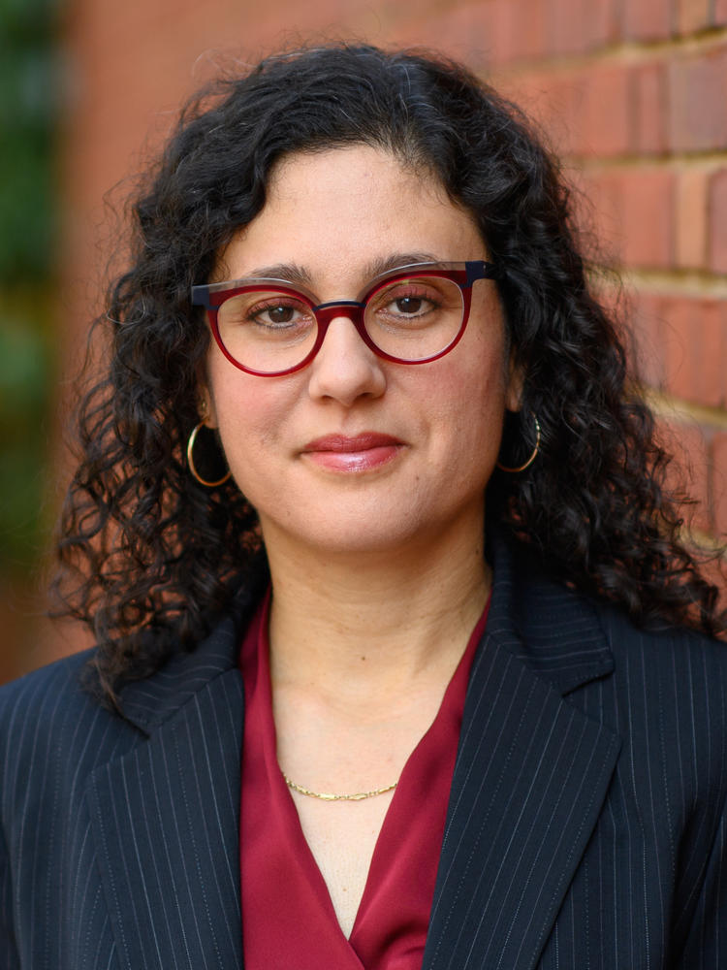

Leah Boustan (Princeton) & Ran Abramitzky (Stanford) Irfhan Rawji
Authors of Streets of Gold Founder & Executive Chair
(All participants will receive a free copy of the book!) MOBSQUAD

