Innovating Sustainability: The Role of Digitalisation in nonlinear international strategies of entrepreneurial firms

Department: College of Business and Social Sciences
Contract Type: Fixed Term
Basis: Full Time
Closing Date: Monday 3rd June at 23.59 (UK time)
Supervisors: Dr Vahid Jafari-Sadeghi and Professor Sangeeta Khorana

Applications are invited for a three-year PhD studentship, supported by the College of Business and Social Sciences to be undertaken within the Department of Economics, Finance and Entrepreneurship at Aston University.

The position is available to start in October 2024.

Financial Support

This studentship includes a bursary to cover the fees rate, plus an annual maintenance allowance of £19,237.

Background to the Project

Aston Business School is excited to offer a research opportunity focused on "Innovating Sustainability: The Role of Digitalisation in nonlinear international strategies of entrepreneurial firms."

This project aligns with Aston University’s 2030 strategic objectives, emphasising innovation, global influence, and sustainability. It represents an interdisciplinary venture, integrating concepts from international entrepreneurship, digital technology, and sustainable development.

The research project is designed to explore the multifaceted dynamics of digitalisation in international entrepreneurship, with a special emphasis on sustainable practices. This investigation is critical in an era marked by rapid technological advancements and increasing environmental concerns. The project aims to contribute to the understanding of how digital innovations can be harmonised with sustainable imperatives in nonlinear international strategies of entrepreneurial firms, addressing key challenges and opportunities in the digital age.

Key Research Areas:

Digital Technologies and Sustainable Practices: Investigating how digital technologies facilitate sustainable practices in international entrepreneurial ventures and identifying the key factors for their successful integration.

Challenges and Opportunities in Digitalisation leading to de/re-internationalisation of entrepreneurial firms.: Exploring the challenges and opportunities presented by digitalisation for achieving sustainability goals leading to nonlinear international strategies (de- and/or re-internationalisation) of entrepreneurial firms, particularly in diverse cultural and regulatory environments.

Impact on Local and Global Sustainability: Assessing the impact of digital transformation on local and global sustainability efforts and the role of entrepreneurial ventures in shaping sustainable development policies.

Methodology:

The research adopts a mixed-methods approach, combining in-depth qualitative analysis with quantitative studies. This includes conducting interviews with international entrepreneurs who have incorporated sustainability into their business models, followed by a broad survey analysis to validate qualitative insights. The project will employ advanced tools for data analysis, including NVivo for qualitative data and statistical software like SPSS or Stata, EViews, and SmartPLS.

Candidate Profile:

We are looking for candidates with a keen interest in international entrepreneurship, digital transformation, and sustainability. Applicants should possess astrong academic background in business, economics, or a related field. Skills in qualitative and quantitative research methodologies are essential. The ideal candidate will be highly motivated, with the ability to work independently and collaboratively, and have excellent communication skills.

Opportunity:

This research opportunity is not only a chance to contribute to an important area of academic study but also offers the potential to influence real-world business practices and policies. The successful candidate will work closely with a team of experienced researchers at Aston Business School and have access to a wide range of resources and networking opportunities. The project's findings are expected to be published in high-impact journals and presented at international conferences.

Person Specification

The successful candidate should hold a Masters degree in business, management, or the social sciences (or related disciplines) with a Merit overall (or equivalent) with a dissertation/research element, PLUS a First or Upper Second Class Honours degree (or an equivalent qualification from an overseas institution).

Contact information

For formal enquiries about this project please contact Dr Vahid Jafari-Sadeghi v.jafari-sadeghi@aston.ac.uk and/or Professor Sangeeta Khorana s.khorana@aston.ac.uk

Submitting an application

Your application must include:
- English language copies of the transcripts and certificates for all your higher education degrees, including any Bachelor degrees.
- A Research Proposal Statement detailing your understanding of the research area, how you would approach the project, and a brief review of relevant literature. Be sure to use the title of the research project you are applying for. There is no set format or word count.
- A personal statement which outlines any further information which you think is relevant to your application, such as your personal suitability for research, career aspirations, possible future research interests, and further description of relevant employment experience.
- Two academic referees who can discuss your suitability for independent research. References must be on headed paper, signed and dated no more than 2 years old. At least one reference should be from your most recent University. You can submit your references at a later date if necessary.
- Evidence that you meet the English Language requirements. If you do not currently meet the language requirements, you can submit this at a later stage.
- A copy of your passport. Where relevant, include evidence of settled or pre-settled status.
Apply for this position here

Alternatively, apply here

Please select:

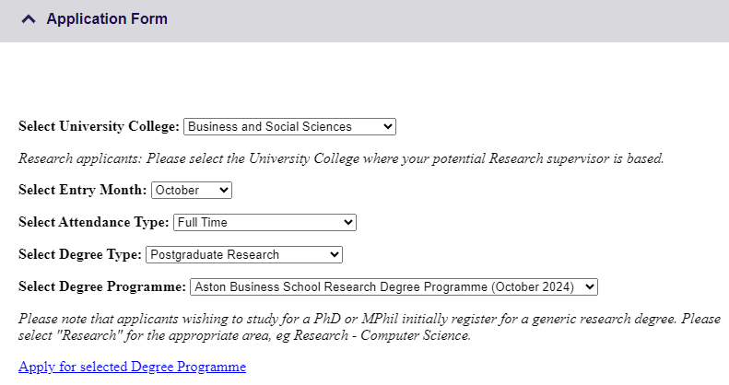

If you require further information about the application process, please contact the Postgraduate Admissions team at pgr_admissions@aston.ac.uk

