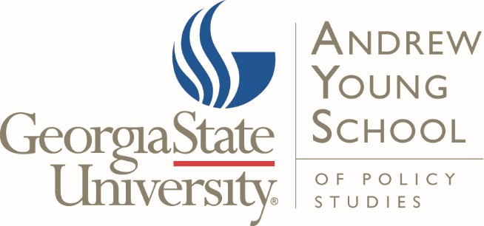

EELE
Associate Professor/Professor Public Economics, Public Finance, Public Budgeting, or Public Financial Management

Position and Responsibilities:
The Andrew Young School of Policy Studies invites applications for a full-time, tenure-track position beginning in August 2020 in the Department of Economics or the Department of Public Management and Policy at the Associate or Full Professor level. Due to an expansion in our evidence-based policy research, we are most interested in an experienced scholar who can make a substantial contribution to our applied public finance research cluster which includes the Center for State and Local Finance, the Fiscal Research Center, and the International Center for Public Policy. The ideal candidate will have interest in a leadership role in the cluster and will be a senior member of one of the academic departments. Applicants should have a primary research and teaching interest in public economics, public finance, public budgeting or public financial management, taxation, as well as strong interests in applied policy research. This position requires a doctorate degree from an accredited university in one of the following fields of study: economics, public policy, political science or public management. The hire will have access to unique administrative data and will be interested in using advanced big data empirical techniques. Responsibilities include teaching, research, and senior leadership of the cluster. The latter will be compensated via administrative release time.

Andrew Young School and Campus Environment:
The Andrew Young School is ranked among the top 20 policy schools in the U.S. The school houses five academic departments and outstanding research centers and institutes in health policy, international and domestic public policy, public finance, experimental economics, urban studies, and education policy, among others. Georgia State University, an enterprising R-1 university located in Atlanta, is a national leader in using innovation to drive student success and research growth. Enrolling and graduating one of the most diverse student bodies in the nation, Georgia State provides its world-class faculty and more than 50,000 students unsurpassed research, teaching, and learning opportunities in one of the 21st century’s great global cities.

For additional information about the Andrew Young School: https://aysps.gsu.edu/

Qualifications:

REQUIRED:
- Ph.D. in economics, public policy, political science or public management
- Primary research and teaching interest in public economics, public finance, public budgeting or public financial management, taxation, as well as strong interests in applied policy research. Interest and experience working with policy makers to identify and deliver on a research agenda that produces causal evidence to inform policy aimed at improving child and family welfare
- Demonstrated success attracting external research funding
- Ability to pass a full background check
- Eligible to work in the U.S.

Condition of Work and Benefits
Forty-hour work week Retirement plans include: Teachers Retirement System,
Twelve paid holidays TIAA, VALIC, & Fidelity
Sick Leave Group health and life insurance
Faculty rank and status Social Security
Tenure track Optional pre-tax benefits
Support for research and professional activities

Salary and Rank
Salary commensurate with the candidate’s education and experience. Appointment at a faculty rank, on a contract renewal basis. This position is subject to budgetary approval.

Submit a cover letter addressing the above qualifications; curriculum vita; name, address and phone number of three references. Review of materials will begin December 13 and continue until the position is filled.

Application submission:

All applications must be submitted through Academic Jobs Online (https://academicjobsonline.org/ajo/jobs/14944). No paper applications will be accepted unless specifically solicited.

Georgia State University is an Equal Opportunity Employer and does not discriminate against applicants due to race, ethnicity, gender, veteran status, or on the basis of disability or any other federal, state, or local protected class. As a university with a diverse student body, we encourage applications from women and minorities.

